**Tools & Technologies**

**Tensor flow**

TensorFlow is a software library for

machine learning and

artificial intelligence.

<https://www.tensorflow.org/>

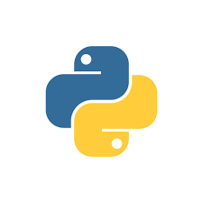**Python**

A versatile, high-level programming language.

<https://www.python.org/>

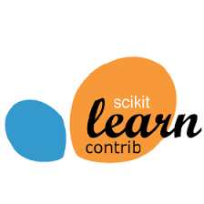**Scikit**

Scikit-learn is probably the most useful

library for machine learning in Python.

<https://scikit-learn.org/stable/>

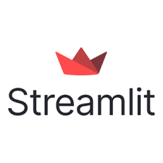**Stream lit**

Stream lit For building interactive

web applications.  
<https://streamlit.io/>

**MySQL**

My SQL Cluster enables users to meet the database challenges of next generation  
<https://www.mysql.com/>

Visual Studio Code

Visual Studio Code for Development <https://code.visualstudio.com>

Jira

Jira for project management and issue tracking

[https://www.atlassian.com](https://www.atlassian.com/software/jira)

Global web icon

Anaconda for Python-based machine learning IDE

<https://www.anaconda.com/>



Allows developers to create, store, manage, and share their code

<https://github.com/>



Working together is easier

with Microsoft Teams

<https://www.microsoft.com/en-us/microsoft-teams/group-chat-software>